**PROJECT II MILESTONEII**

CREATE TABLE Department (

departmentID tinyint PRIMARY KEY,

department_name varchar(30)

);

CREATE TABLE Customer (

custID tinyint PRIMARY KEY,

name varchar(40),

gender CHAR(1) not null,

year_of_birth smallint not null,

address varchar(40),

postal_code varchar(10),

city varchar(30),

phone varchar(10),

comment varchar(200),

CONSTRAINT CHK_Year CHECK (year_of_birth between 1930 AND 2005),

check(gender in ('M', 'F', 'U'))

);

CREATE TABLE Employee (

employeeID tinyint PRIMARY KEY,

employee_name varchar(30),

commission DECIMAL(10,2));

CREATE TABLE Payment (

custID tinyint,

postal_code varchar(10),

department varchar(30),

amount varchar(6),

orderID tinyint PRIMARY KEY,

FOREIGN KEY (custID) References Customer(custID)

);

CREATE TABLE EmployeeDepartment (

employeeID tinyint,

departmentID tinyint,

FOREIGN KEY (employeeID) References Employee(employeeID),

FOREIGN KEY (departmentID) References Department(departmentID)

);

INSERT INTO Department (departmentID, department_name)

VALUES

('01', 'style'),

('02', 'layouts'),

('03', 'biographies'),

('04', 'pedigree_search'),

('05', 'main_galleries'),

('06', 'schemes'),

('07', 'fonts'),

('08', 'videos'),

('09', 'links');

INSERT INTO Customer (custID, name, gender, year_of_birth, address, postal_code, city, phone, comment)

VALUES

('01', 'Nancy', 'F', '1967', '300 Sight st', '65412', 'Louis', '2001236677', 'good standing'),

('02', 'Greg', 'M', '1968', '300 North st', '65414', 'Alton', '2001236688', 'good standing'),

('03', 'Bob', 'M', '1969', '300 South st', '65415', 'Burg', '2001299677', 'good standing');

INSERT INTO Employee (employeeID, employee_name, commission)

VALUES

('01', 'Jack', '1000.00'),

('02', 'Robert', '2000.00'),

('03', 'Susan', '3000.00');

INSERT INTO Payment (custID, postal_code, department, amount, orderID)

VALUES

('01', '65412', 'post', '2000', '12'),

('02', '65414', 'pre', '3000', '13'),

('03', '65415', 'in_process', '1000', '14'),

('01', '65412', 'post', '4000', '15');

INSERT INTO EmployeeDepartment (employeeID, departmentID)

VALUES

('01', '01'),

('01', '02'),

('01', '03'),

('02', '04'),

('02', '05'),

('02', '06'),

('03', '07'),

('03', '08'),

('03', '09');

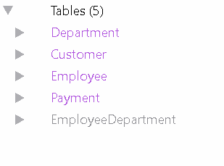

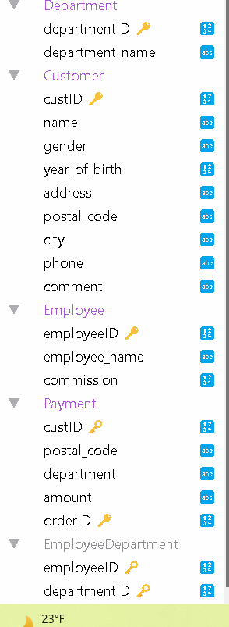

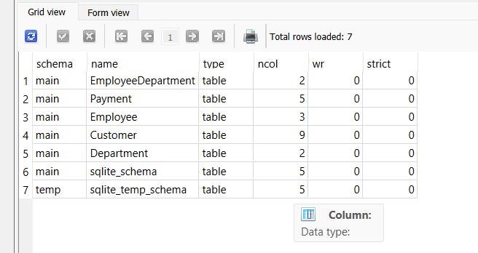

**Queries:**

SELECT

custID, postal_code, department, amount, orderID,

RANK() OVER (ORDER BY amount DESC)

FROM Payment;

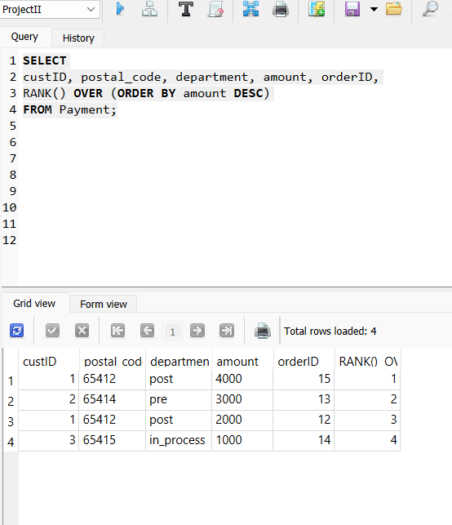

SELECT *

FROM Payment

WHERE amount = (SELECT MAX(amount) FROM Payment);

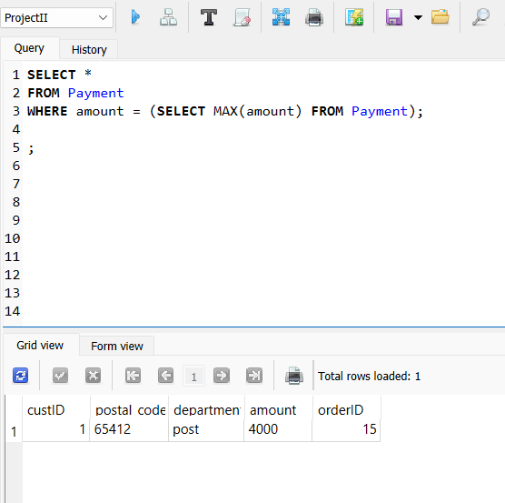

SELECT

Department.department_name,

EmployeeDepartment.departmentID,

EmployeeDepartment.employeeID * Department.departmentID

FROM Department

CROSS JOIN EmployeeDepartment

|  |  |  |
| --- | --- | --- |
| style | 1 | 1 |
| style | 2 | 1 |
| style | 3 | 1 |
| style | 4 | 2 |
| style | 5 | 2 |
| style | 6 | 2 |
| style | 7 | 3 |
| style | 8 | 3 |
| style | 9 | 3 |
| layouts | 1 | 2 |
| layouts | 2 | 2 |
| layouts | 3 | 2 |
| layouts | 4 | 4 |
| layouts | 5 | 4 |
| layouts | 6 | 4 |
| layouts | 7 | 6 |
| layouts | 8 | 6 |
| layouts | 9 | 6 |
| biographies | 1 | 3 |
| biographies | 2 | 3 |
| biographies | 3 | 3 |
| biographies | 4 | 6 |
| biographies | 5 | 6 |
| biographies | 6 | 6 |
| biographies | 7 | 9 |
| biographies | 8 | 9 |
| biographies | 9 | 9 |
| pedigree_search | 1 | 4 |
| pedigree_search | 2 | 4 |
| pedigree_search | 3 | 4 |
| pedigree_search | 4 | 8 |
| pedigree_search | 5 | 8 |
| pedigree_search | 6 | 8 |
| pedigree_search | 7 | 12 |
| pedigree_search | 8 | 12 |
| pedigree_search | 9 | 12 |
| main_galleries | 1 | 5 |
| main_galleries | 2 | 5 |
| main_galleries | 3 | 5 |
| main_galleries | 4 | 10 |
| main_galleries | 5 | 10 |
| main_galleries | 6 | 10 |
| main_galleries | 7 | 15 |
| main_galleries | 8 | 15 |
| main_galleries | 9 | 15 |
| schemes | 1 | 6 |
| schemes | 2 | 6 |
| schemes | 3 | 6 |
| schemes | 4 | 12 |
| schemes | 5 | 12 |
| schemes | 6 | 12 |
| schemes | 7 | 18 |
| schemes | 8 | 18 |
| schemes | 9 | 18 |
| fonts | 1 | 7 |
| fonts | 2 | 7 |
| fonts | 3 | 7 |
| fonts | 4 | 14 |
| fonts | 5 | 14 |
| fonts | 6 | 14 |
| fonts | 7 | 21 |
| fonts | 8 | 21 |
| fonts | 9 | 21 |
| videos | 1 | 8 |
| videos | 2 | 8 |
| videos | 3 | 8 |
| videos | 4 | 16 |
| videos | 5 | 16 |
| videos | 6 | 16 |
| videos | 7 | 24 |
| videos | 8 | 24 |
| videos | 9 | 24 |
| links | 1 | 9 |
| links | 2 | 9 |
| links | 3 | 9 |
| links | 4 | 18 |
| links | 5 | 18 |
| links | 6 | 18 |
| links | 7 | 27 |
| links | 8 | 27 |
| links | 9 | 27 |

**Reflection:**

I need more time to expand my knowledge on creating SQL databases and populating them with more data so that I can run more complex queries. This learning experience has proved harder than I had originally thought, but it was a fun experience to get one up and running in its most bare form.